ASET Center Selected for the EU’s Elite “Pathways2Resilience” Programme

A group of 62 European regions (full list), identified as the most vulnerable to climate change, have been selected to engage in Pathways2Resilience, a flagship project of the EU Mission on Adaptation to Climate Change. Launched in 2023, the programme now includes 100 local and regional authorities representing more than 100 million citizens..

ASET Center will have access to tailored tools, professional mentoring, peer learning, and guidance from international experts.
Objective: Over an 18-month period, Tirana County, in cooperation with ASET Center, will develop an effective strategy to enhance resilience to climate change, as well as a concrete action and investment plan.
About Pathways2Resilience
Pathways2Resilience is a flagship project of the EU Mission on Adaptation to Climate Change.
EU Missions are new instruments designed to accelerate the implementation of the European Green Deal across five areas, including climate adaptation. For more information, visit www.pathways2resilience.eu


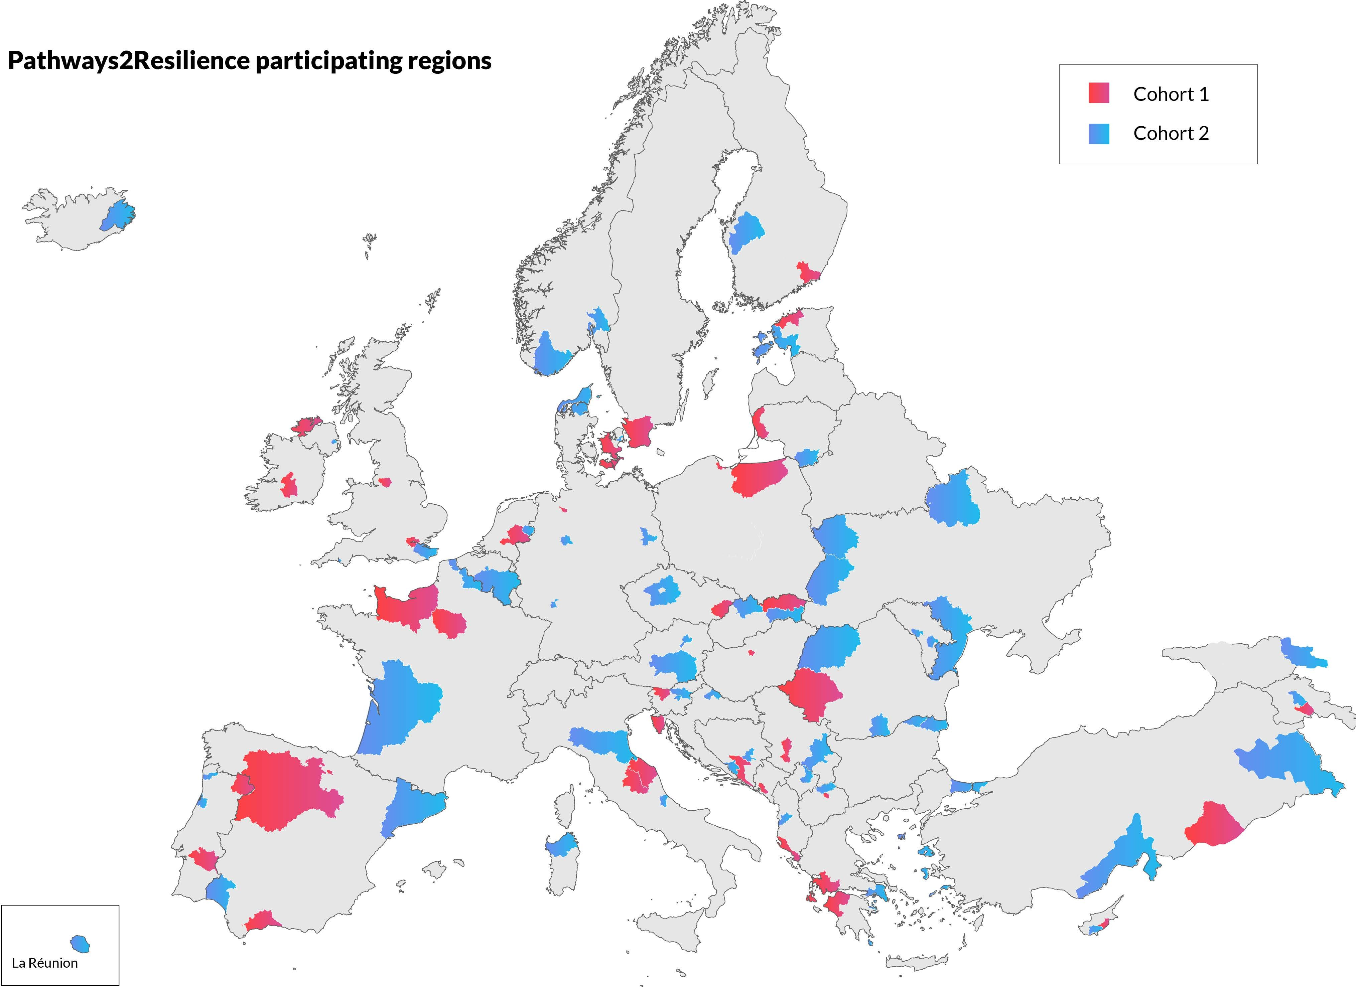


www.Pathways2resilience.eu/ hello@pathways2resilience.eu

@Pathways2Resilience

